**TRANSIENT AERODYNAMIC CHARACTERISTICS OF AN AIRFOIL**



**PROJECT REPORT**

**SUBMITTED IN PARTIAL FULFILLMENT OF THE REQUIREMENTS FOR THE AWARD OF THE DEGREE OF**

**Bachelor of Technology**

**In**

**Mechanical Engineering**

***Submitted By***

**Rohit Varshney, 19MEB326**

**Sandeep Kumar, 19MEB418**

**Midlaj kk, 19MEB511**

**Harsh Yadav, 19MEB517**

***Under the supervision of***

**Prof. NADEEM HASAN**

**Department of Mechanical Engineering**

**Zakir Husain College of Engineering Technology**

**Aligarh Muslim University, Aligarh**

**2022-2023**

# ACKNOWLEDGEMENT

First of all, we are thankful to the Almighty God, we extend our thanks to supervisors and our beloved classmates for the successful completion of this report.

We avail this opportunity to express with utmost sincerity, our heartfelt thanks to **Dr. Nadeem Hasan** of Department of Mechanical Engineering department, for their erudite guidance and suggestions, timely help and critical evaluation of our work without which it would not have been possible for us to carry out our critical review, project work and its final culmination into this project report.

We also express our gratitude towards the department for the various facilities provided. Further we would like to thank our families for their valuable contributions and keeping us motivated throughout our work.

### ABSTRACT

This is an investigation into the unsteady aerodynamics of an accelerating airfoil NACA0012 . The main objective of the study is to compare the unsteady flow fields and the aerodynamic forces and moments resulting from acceleration or retardation of airfoil NACA0012 with the corresponding steady state results at specific Mach numbers. It is to focus on subsonic Mach numbers using two-dimensional numerical models of airfoils and axisymmetric bodies. The geometrical designing and mesh generation of the airfoil is done using conventional programming and the computational analysis is carried out using (PVU-M+) method. The analysis is fully based upon the concepts of Finite Volume Method and CFD.

### TABLE OF CONTENTS

TABLE OF CONTENTS II

NOTATIONS III

LIST OF FIGURES IV

LIST OF TABLES VI

CHAPTER 1: INTRODUCTION 7

CHAPTER 2: LITERATURE REVIEW 10

CHAPTER 3: PROBLEM FORMULLATION/ STATEMENT 12

CHAPTER 4: MODELING METHODOLOGY 14

CHAPTER 5:CONCLUSION AND FUTURE WORKS 28

REFERENCES 29

### NOTATIONS

|  |  |
| --- | --- |
| **Re**  **Ma** | Reynolds number  Mach number |
| α | Angle of attack |
| **CL** | Lift of Coefficient |
| **Cd** | Drag Coefficient |
| **t** | Time |
| **ρ** | Density |
| **T**  **x, y**  **E**  **Cv**  **Cp**  **C**  **µ**  **K**  **h** | Temperature  Space Co-Ordinates  Total Specific energy  Specific heat at Constant volume  Specific heat at Constant Pressure  Chord length  Viscosity  Thermal Conductivity  Total Specific Enthalpy |

|  |  |
| --- | --- |
|  |  |

|  |  |
| --- | --- |
|  |  |

**LIST OF FIGURES**

Figure 1.1 Steady state flow field 7

Figure 1.2 The unsteady flow field 7

Figure 1.3 Unsteady flow field with particle moving at subsonic velocity 7

Figure 4.1 Flow Field plotted for M=0.5 and viscous flow at Statistically Steady State 15

Figure 4.2 Lift VS Time for Ma=0.5 and at Statistically Steady State 17

Figure 4.3 Cd vs α 17

Figure 4.4 CL vs α 18

Figure 4.5 18

Figure 4.6 Flow Field plotted for M=0.5 and viscous flow at marked point. 20

Figure 4.7 Lift Vs Time for Ma=0.5 and at marked point 21

Figure 4.8 Averaged vorticity contour plotted for Ma=0.5 and viscous flow at marked point 22

Figure 4.9 Lift and Drag vs time at Ma=0.5 and Viscous flow for marked point 23

Figure 4.10 O structured grid 24

Figure 4.11 Input Parameters of inviscid flow conditions 25

Figure 4.12 Applying Boundary Conditions 25

Figure 4.13 Lift versus Time 26

Figure 4.14 Comparisons of drag and lift at different Mach and Angle of Attack 26

Figure 4.15 Comparison of Lift and Drag Ansys results and PVU-M+ method 27

### LIST OF TABLES

Table 4.1 Comparing Cd and Cl from research paper. 17

Table 4.2 Solver2Dm_latest.f90 results at marked point. 23

Table 4.3 Comparison of Ansys results and PVU-M+ method 27

# CHAPTER 1: INTRODUCTION

In the past, when studying objects moving through compressible fluids, nearly all the work was conducted on movement at constant speed through the fluid [2]. This was seldom extended to accelerating bodies, even though in many practical applications objects experience acceleration and retardation. For example when graphs of the variation of lift or drag versus Mach number were plotted for an aerofoil, these were based on steady state flight [4, 5, 6]. In other words sufficient time was allowed to lapse at each specific Mach number for aerodynamic equilibrium to be reached, before the lift or drag forces were determined. However, in accelerated motion there is no time for equilibrium to be reached at each Mach number. Therefore the graph of lift or drag versus Mach number for an accelerating body should differ from the steady state case.

The main reason for this expected difference is that the unsteady flow field generated during acceleration or retardation differs from the steady state flow field at the same instantaneous Mach number. An example of this for the simple case of a particle moving through a compressible medium is given in Lilley [1].

In figures 1.1 the steady state disturbances generated by particles moving at constant subsonic and supersonic velocities are shown. Figure 1.2 shows an unsteady supersonic scenario, where the particle is accelerated from subsonic to supersonic velocities. The distinct difference between the steady and unsteady supersonic cases is evident. In figure 1.3 the particle is moving at a subsonic Mach number after having been accelerated to supersonic Mach numbers followed by retardation to subsonic velocities. The unsteady disturbance generated is very different to the steady subsonic case of figure 1.1.

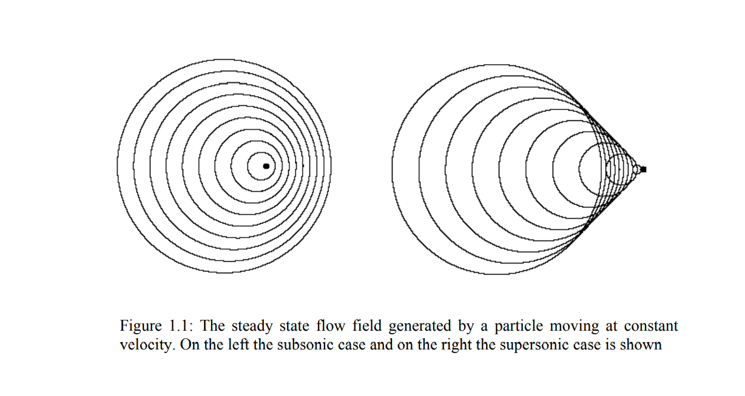

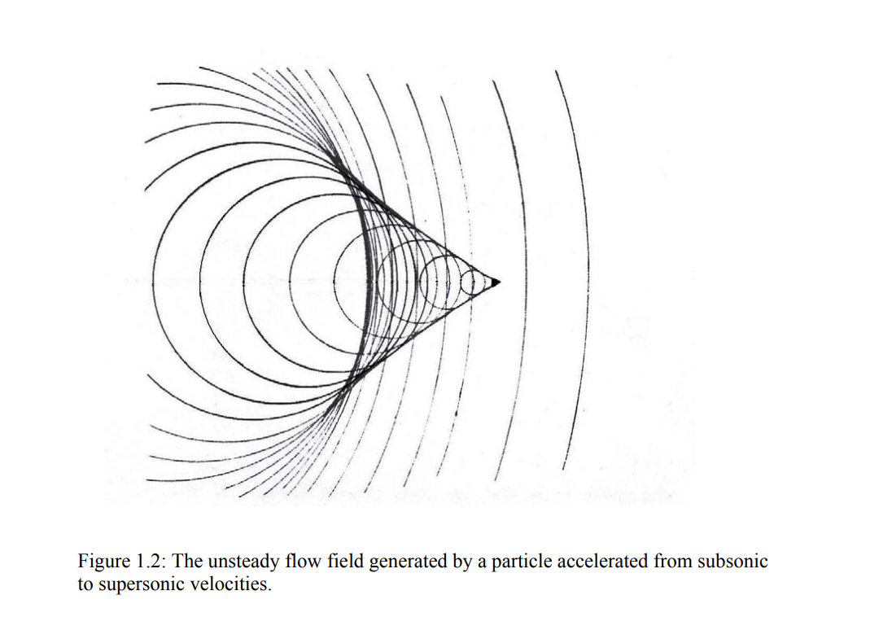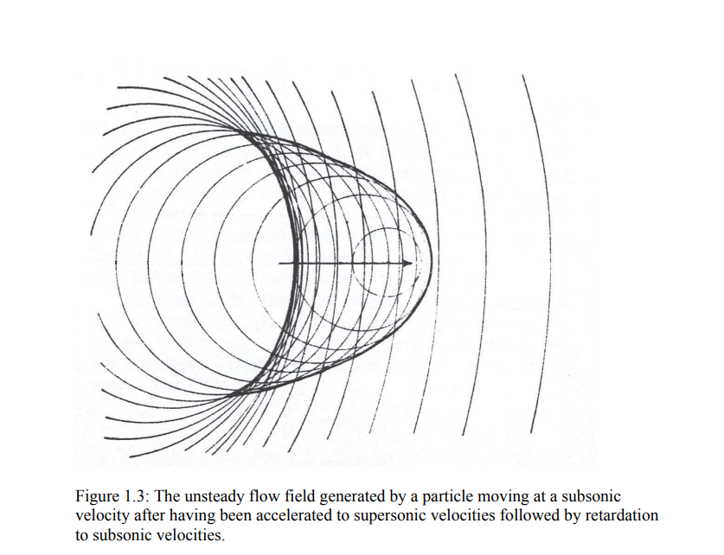

It can be concluded that, if for a moving particle such significant differences exist between the steady and the unsteady flow fields at similar Mach numbers, for a more complex object the differences could even be greater. This would in turn result in differences in the pressure distribution on the surfaces of the object, which would thus affect the aerodynamic forces.

Such studies of unsteady aerodynamics have many practical applications. For example, the study of forces on aircraft during takeoff and landing, the forces acting on fighter planes during acceleration and retardation and the aerodynamics around Formula 1 and other racing cars, which are designed to make use of aerodynamic forces to achieve stability around high speed bends [7]. Also, when designing missiles, the very high accelerations make it necessary to model the unsteady aerodynamic effects [8].

From the above discussion it is clear that the study of accelerated motion in compressible fluids is important. However, in the past research in this field has been limited for the following reasons:

1. It is difficult to mathematically model fluid behavior when an object is accelerated in compressible fluids.
2. Experimental techniques cannot easily be used to measure transient effects caused by accelerating bodies, especially at high velocities.
3. Computation techniques were not sufficiently developed in the past.

Although the first two limitations still apply recent developments in Computational Fluid Dynamic (CFD) techniques have facilitated the study of unsteady effects caused by the acceleration and retardation of moving bodies in compressible fluids. However, this is best achieved by a comparative study of the steady and unsteady cases, which necessitates the use of both steady and unsteady computational models.

# CHAPTER 2: LITERATURE REVIEW

**Victoria Rolandi et al.**[15] investigated stability of the low Reynolds number compressible flow past a NACA0012 airfoil. The unsteady flow past the airfoil at Re = 1000 is characterized using direct numerical simulations for various angles of attack αϵ[0◦, 20◦] and Mach numbers up to M = 0.5. Steady flows obtained using the selective frequency damping (SFD) technique are used as base states for a global linear stability analysis. For α < 20◦, compressibility has a destabilizing effect close to the critical threshold.Where as frequency of the most unstable mode decreases as α or Re increases.

Many of the recent developments regarding accelerating flow around aerofoils is focused on flow oscillations or periodic flow. Selerowicz and Szumowski [10] presented an experimental study on the effect of background flow oscillation on a NACA 0012 aerofoil in a transonic wind tunnel. Pressure history at selected points on the surface of the airfoil as well as interferometric photographs of oscillating aerofoil flow was shown for two different angles of attack. The influence of the unsteady loading on flow separation and reattachment at the higher angle of attack highlight the significant effect of flow oscillation on transonic aerofoil aerodynamics.

Other experimental work using liquids, such as oil mixtures and water with solid tracers used for flow visualization [11], or a piston driven water tunnel with particle image velocimetry (PIV) techniques [12], have been effective in reducing the pressure gradient problem encountered in wind tunnel models during acceleration. These experimental models have been used to improve numerical techniques developed for low Reynolds number applications. However, as liquids are almost incompressible they are not suitable for modelling compressible fluid behaviour at high Reynolds numbers.

Ellsworth and Mueller [13] used hot wire anemometry to determine the effect of an accelerating free stream, from a non-zero velocity, on transitional separation bubble characteristics formed on a Wortmann FX 63-137 aerofoil at 7° angle of attack. This was compared to the characteristics resulting from a quasi-steady velocity change. A wind tunnel was used with the means to generate short-term flow acceleration or deceleration. Although the study was conducted for Reynolds numbers well below the critical value, it is a good example of how the position of the separation bubble is affected by acceleration or deceleration.

It must be noted however, that the accelerating aerofoil offers a closer representation of the moving object in stationary fluid, which is the focus of this study. Through numerical simulations, it will be shown in future chapters that for subsonic velocities, the lift forces on an aerofoil during constant acceleration show a reduction in comparison with the steady state values. This is a confirmation of the results obtained by Sawyer and Sullivan [14]. On the other hand, Sawyer and Sullivan’s experimental model, which involves the acceleration of an aerofoil from rest over a distance of a few feet, is not suitable for validating numerical data at high subsonic and transonic velocities.

**CHAPTER 3: PROBLEM FORMULATION/STATEMENT**

One of the most basic problems of unsteady aerodynamics is the calculation of forces on an airfoil. When an airfoil at an angle of attack starts from rest or accelerated from a constant speed, a circulation is generated around the airfoil and a vortex sheet shed in the wake. During the fast unsteady motion of the airfoil new layers of strong vorticity are formed near the upper and lower surfaces of the airfoil under the previously existing thick vorticity layer, and it is the generation and motion of the new vorticity layers that is mainly responsible for the generation of the large aerodynamic force. The present work examines the evolution of lift as a result of applied acceleration.

#### 3.1 GOVERNING EQUATION:

The continuity, momentum, and energy equations in the Cartesian coordinate system in two dimensions are given below in a generalised form with the addition of body force.

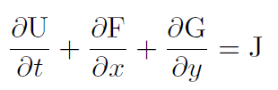

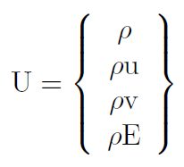

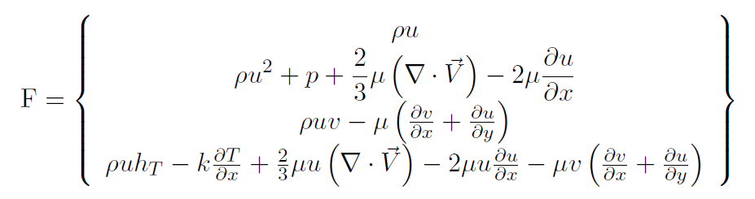

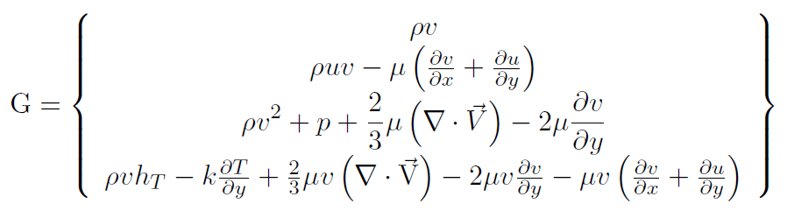

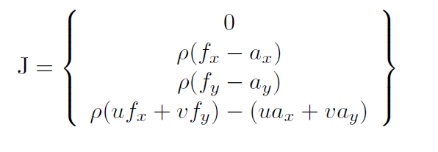

Where :

E is the total specific energy given by

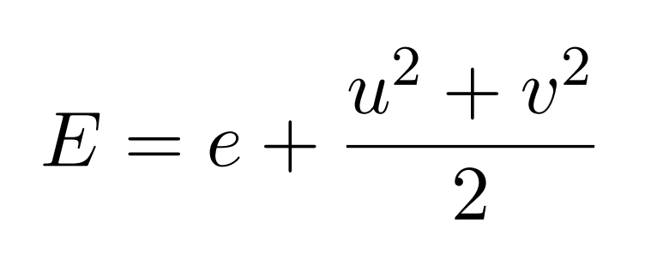

*hT* is the total specific enthalpy given by

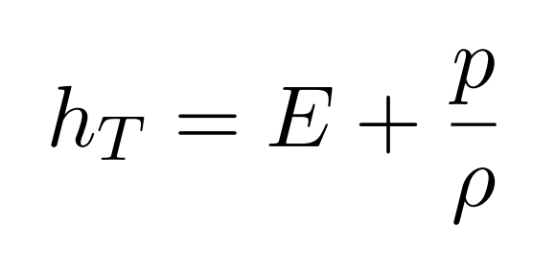

The equation of state for perfect gas is

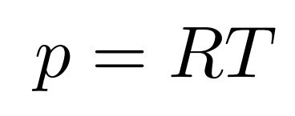

where R is the gas Constant R= Cp - Cv and **γ = $\frac{Cp}{Cv}$**

**CHAPTER 4: MODELING METHODOLOGY**

#### 4.1 DESIGN METHODOLOGY:

A numerical validation of the PVU-M+[16] technique is achieved by comparing results from Rolandi[7] with those obtained from PVU-M+. PVU-M+ Method is designed to the stationary object in a flowing fluid, which is a direct representation of the physical situation being modelled. We run the program Solver2Dm_latest.f90 at time step = E-6, R= 60, domain Dimension=279*420 and C=1. After starting the flow, there is increasing in the lift coefficient at the marked point given in fig.1. in order to understand this trend, we need to achieve the flow field at this point, so we ran the program till this point for same flow conditions. Values of Cd and Cl at the marked point are given in the Table

**4.1(I) Flow Field plotted for M=0.5 and viscous flow at Statistically Steady State**

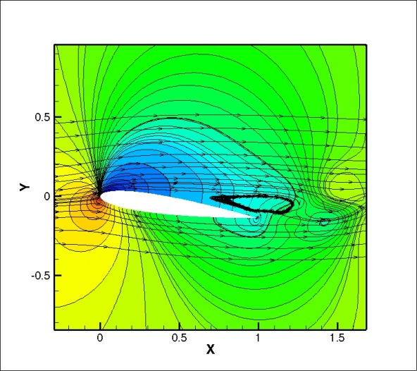 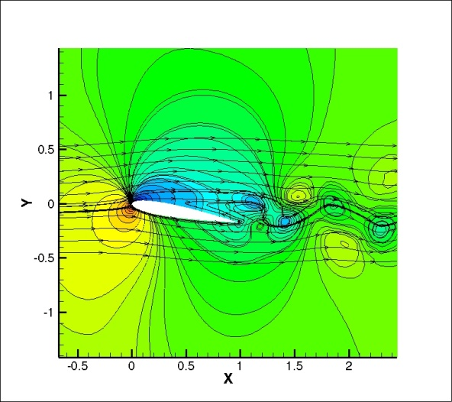

1. α= 8o

(b) α= 9o

 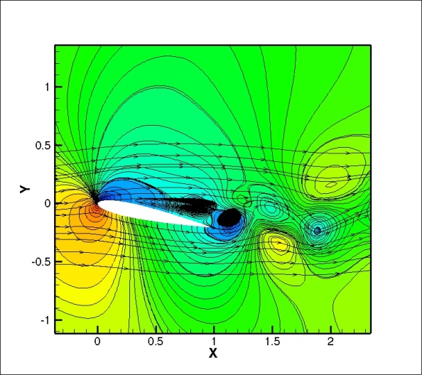

(d) α= 12o

(c) α= 10o

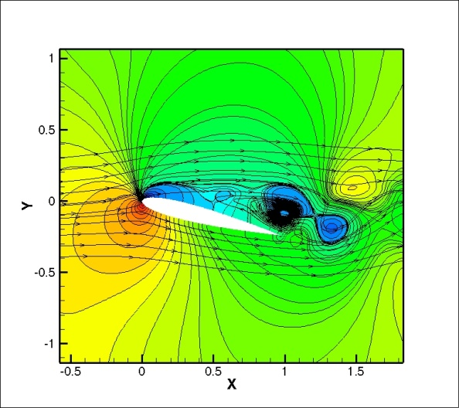 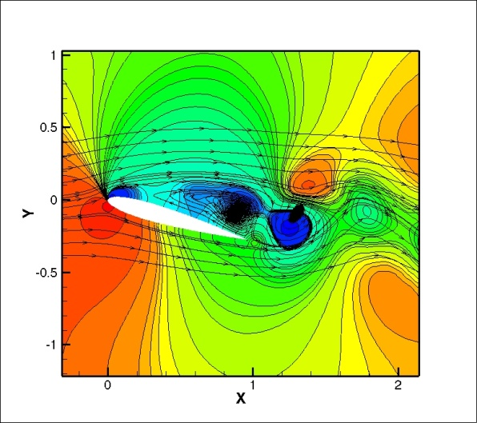

(f) α= 16o

(e) α= 14o

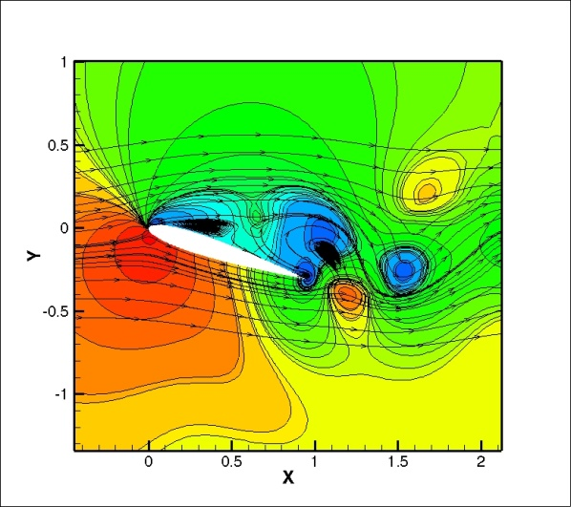

(g) α= 18o

Fig 4.1 Flow Field plotted for M=0.5 and viscous flow at Statistically Steady State

**4.1(II) Lift VS Time for Ma=0.5 and at Statistically Steady State**

1. α= 8o

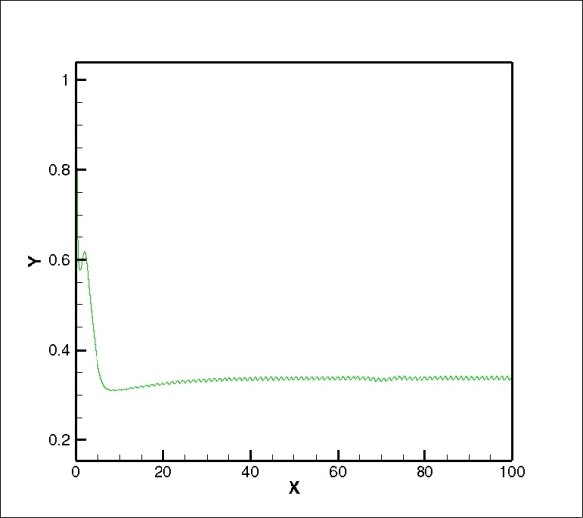 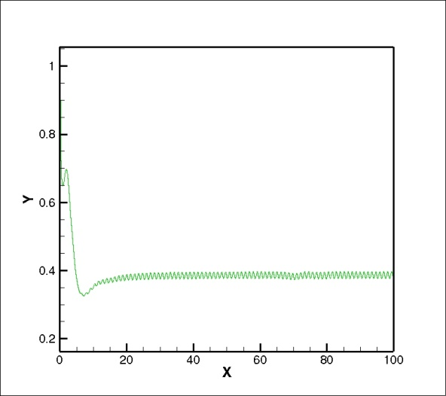

(b) α= 9o

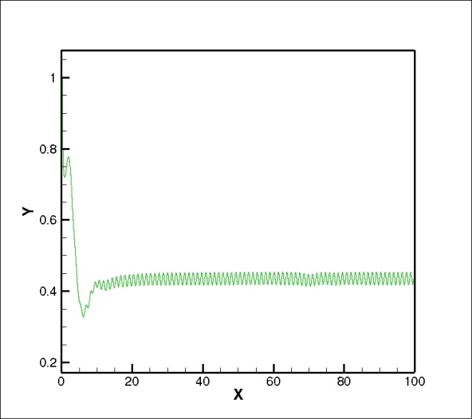 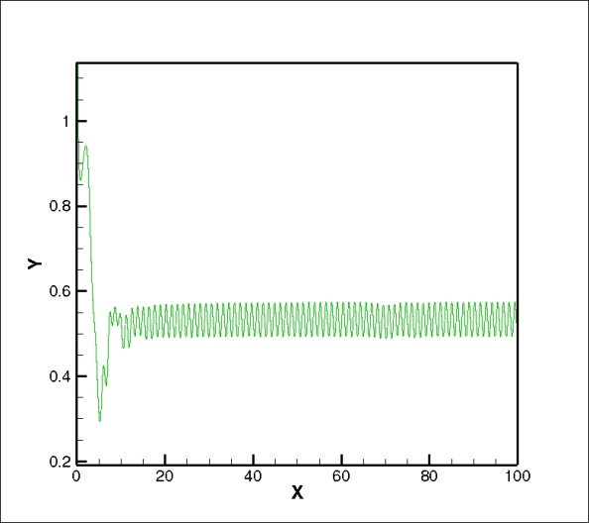

(d) α= 12o

(c) α= 10o

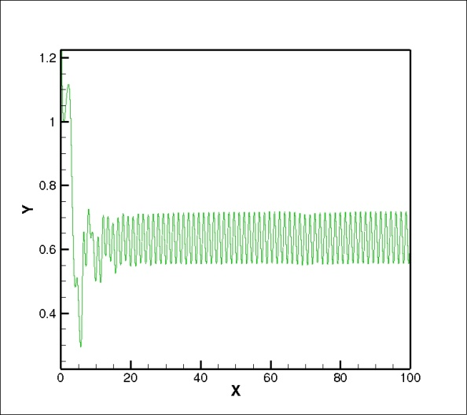 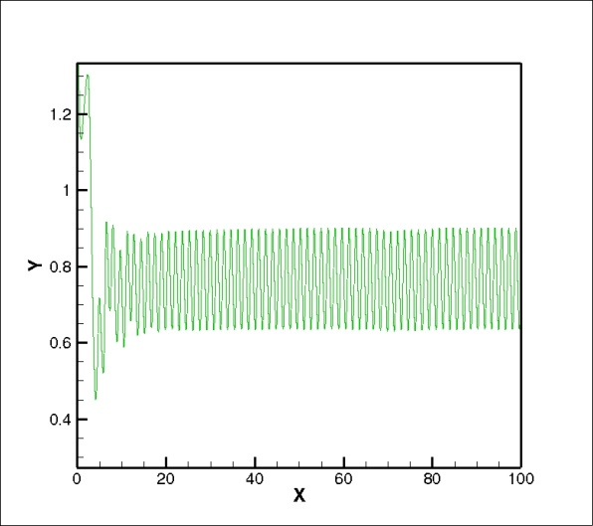

(f) α= 16o

(e) α= 14o

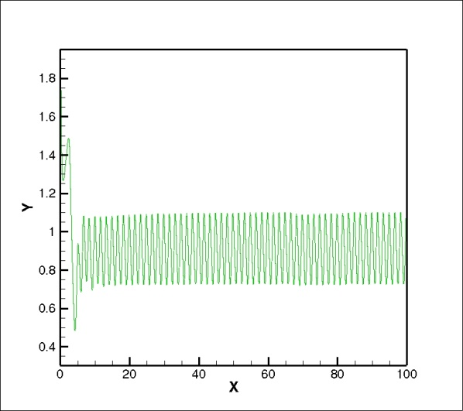

Fig 4.2 Lift VS Time for Ma=0.5 and at Statistically Steady State

(g) α= 18o

**4.1(III) Validation of obtained result:**

|  |  |  |  |  |
| --- | --- | --- | --- | --- |
| At 0.5 Mach | Cd | | Cl | |
| Different Angle of Attacks | Obtained Value | From paper | Obtained Value | From paper |
| 8 | 0.158 | 0.156 | 0.336 | 0.34 |
| 9 | 0.171 | 0.171 | 0.386 | 0.386 |
| 10 | 0.187 | 0.186 | 0.435 | 0.436 |
| 12 | 0.225 | 0.223 | 0.532 | 0.532 |
| 14 | 0.273 | 0.223 | 0.633 | 0.658 |
| 16 | 0.337 | 0.338 | 0.763 | 0.784 |
| 18 | 0.419 | 0.418 | 0.906 | 0.908 |
| 20 | 0.491 | 0.495 | 0.992 | 1.018 |

Table 4.1 Comparing Cd and Cl from research paper

Fig 4.3 Cd vs α

Fig 4.4 CL vs α

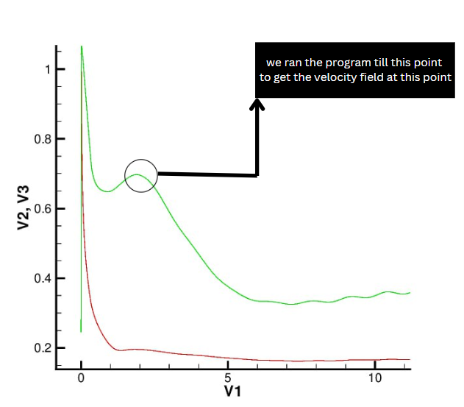

Fig 4.5

**4.1(IV) Flow Field plotted for M=0.5 and viscous flow at marked point** 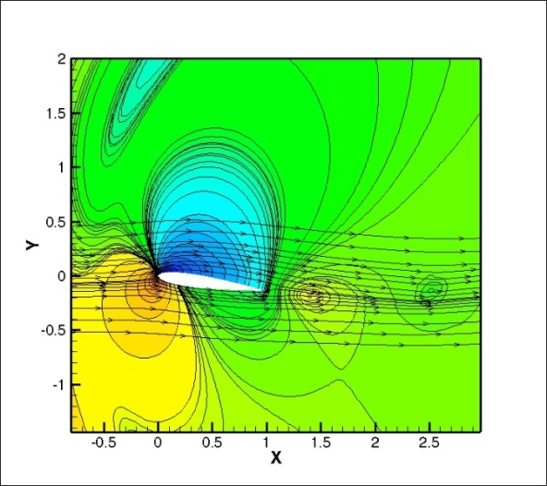 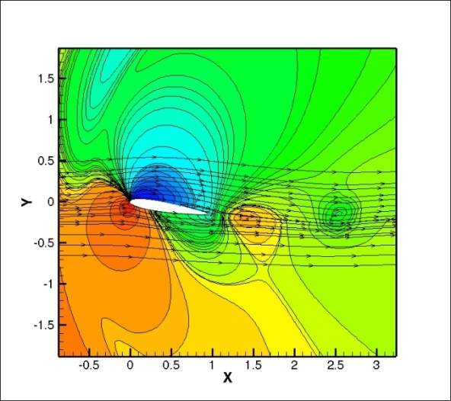

1. α= 8o
2. α= 9o

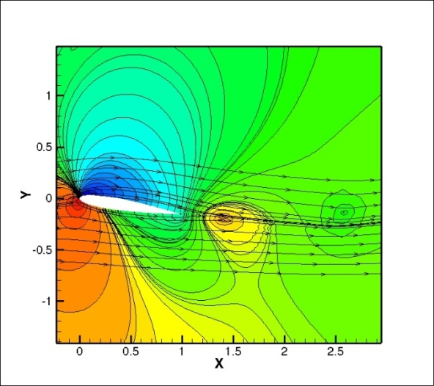 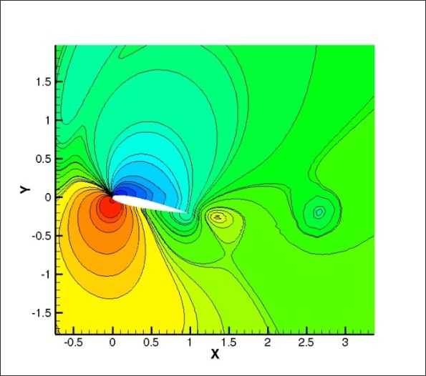

(d) α= 12o

(c) α= 10o

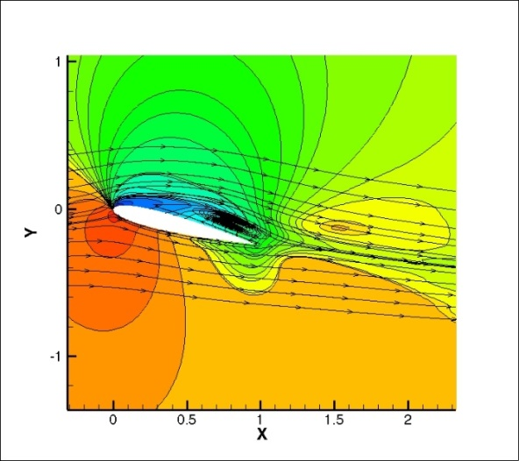 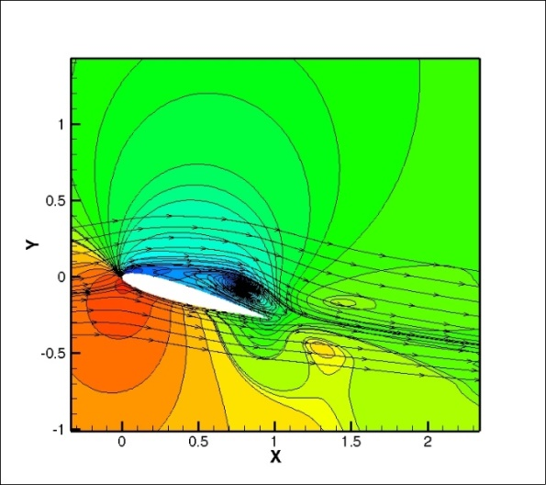

(f) α= 16o

(e) α= 14o

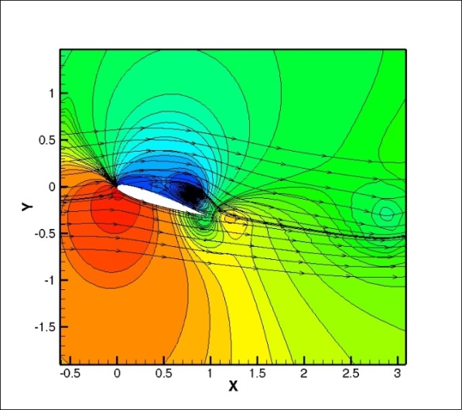

(f) α= 18o

Fig 4.6 Flow Field plotted for M=0.5 and viscous flow at marked point

**4.1(V) Lift VS Time for Ma=0.5 and at marked point**

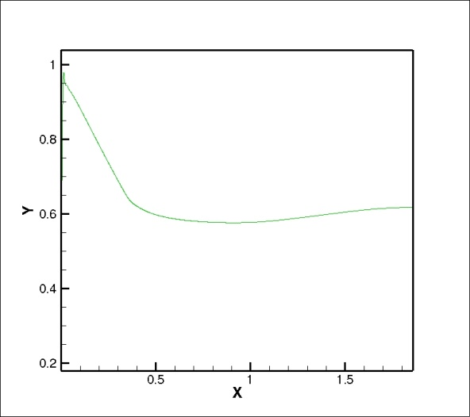 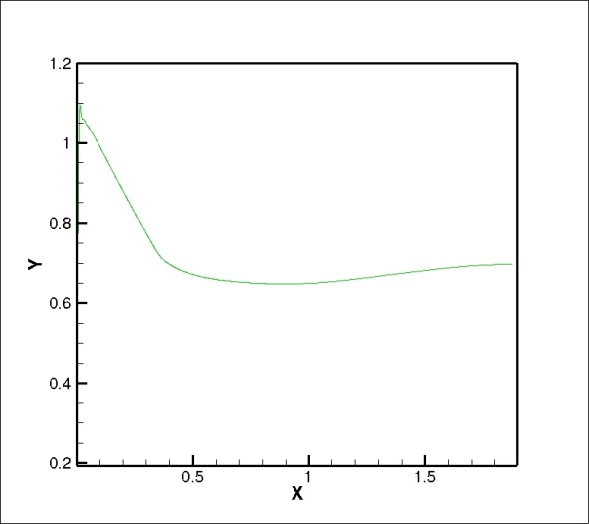

1. α= 8o

(b) α= 9o

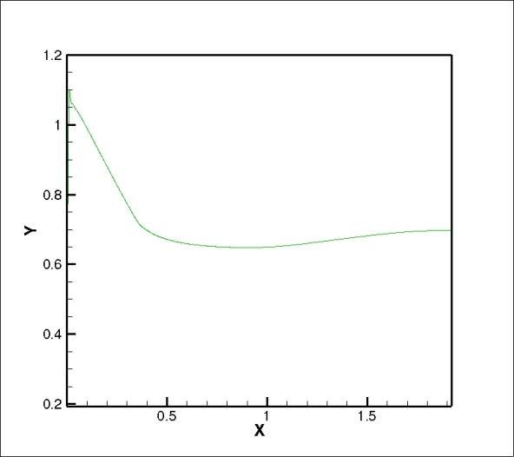 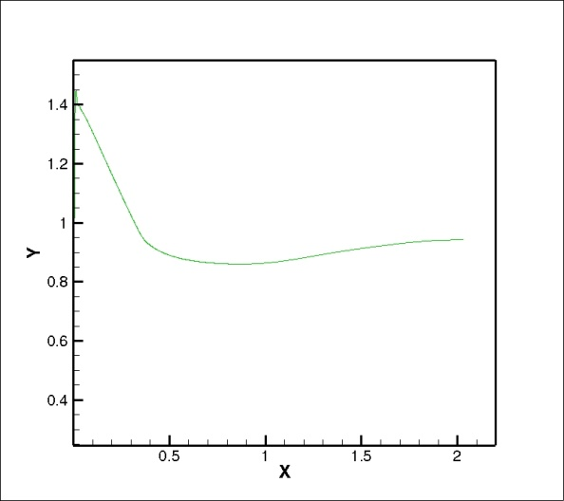

(d) α= 12o

(c) α= 10o

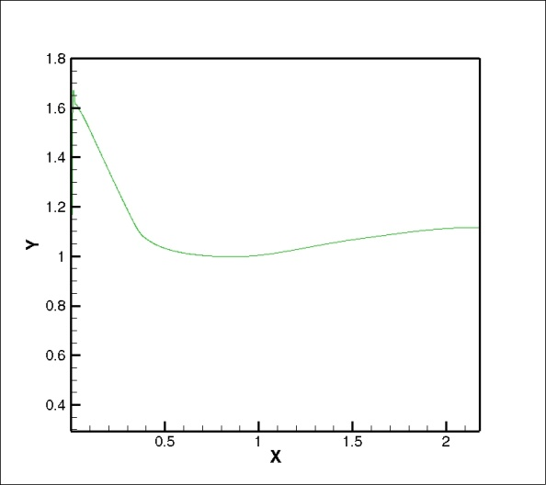 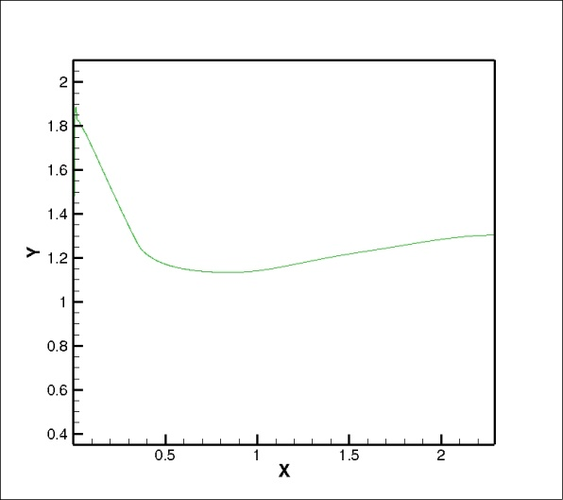

(f) α= 16o

(e) α= 14o

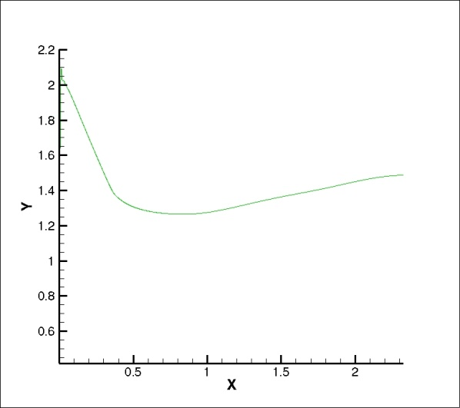

Fig 4.7 Lift VS Time for Ma=0.5 and at marked point

(g) α= 18o

**4.1(VI) Averaged vorticity contour plotted for M=0.5 and viscous flow at marked point**

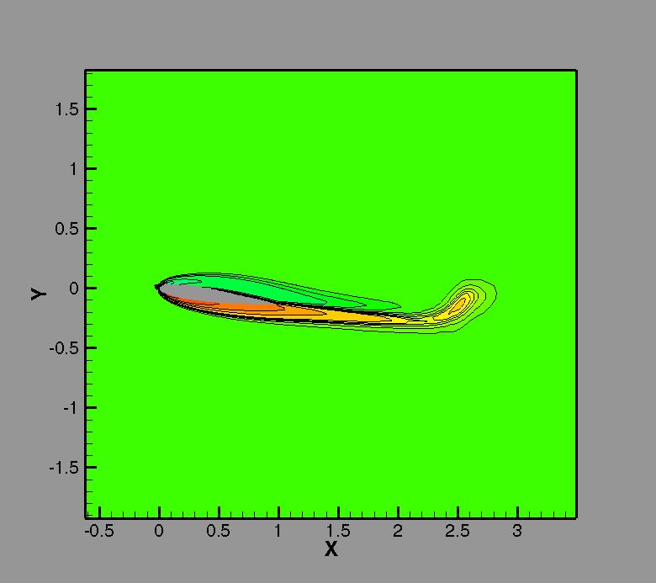 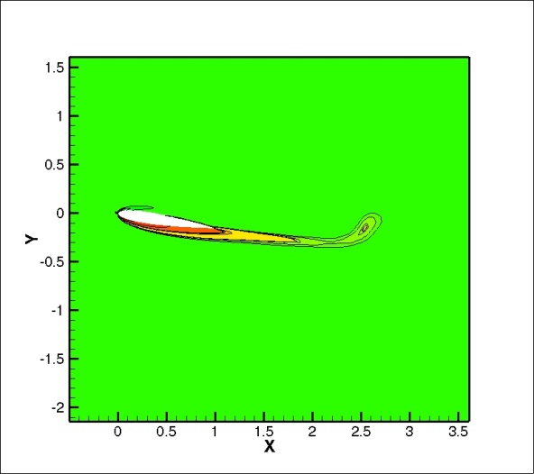

(a) α= 8o

(b) α= 9o

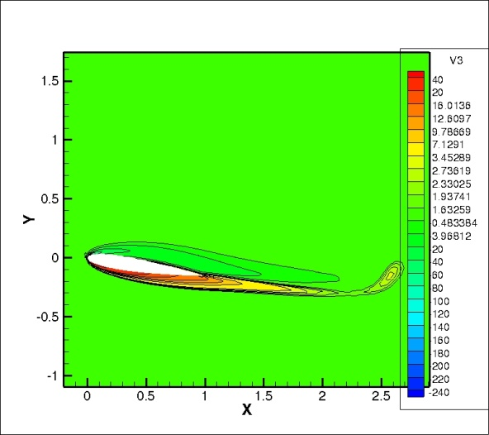 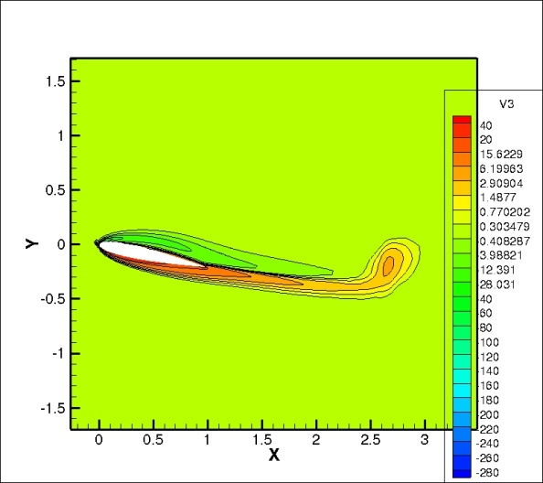

(d) α= 12o

(c) α= 10o

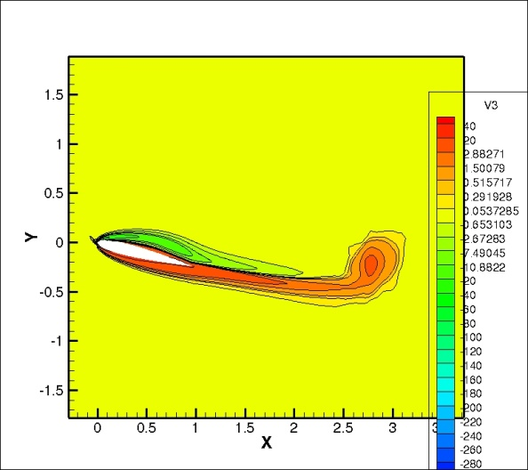 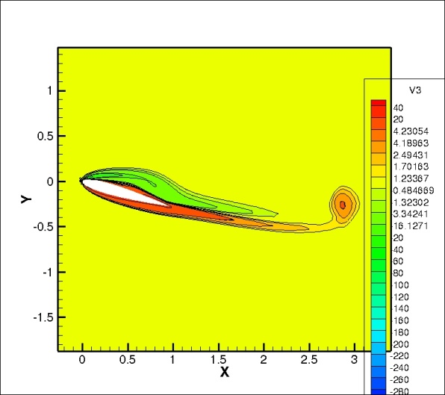

(f) α= 16o

(e) α= 14o

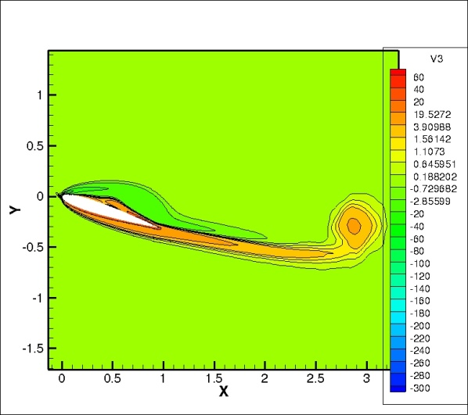

Fig 4.8 Averaged vorticity contour plotted for M=0.5 and viscous flow at marked point

(g) α= 18o

**4.1(VII) Solver2Dm_latest.f90 results at marked point**

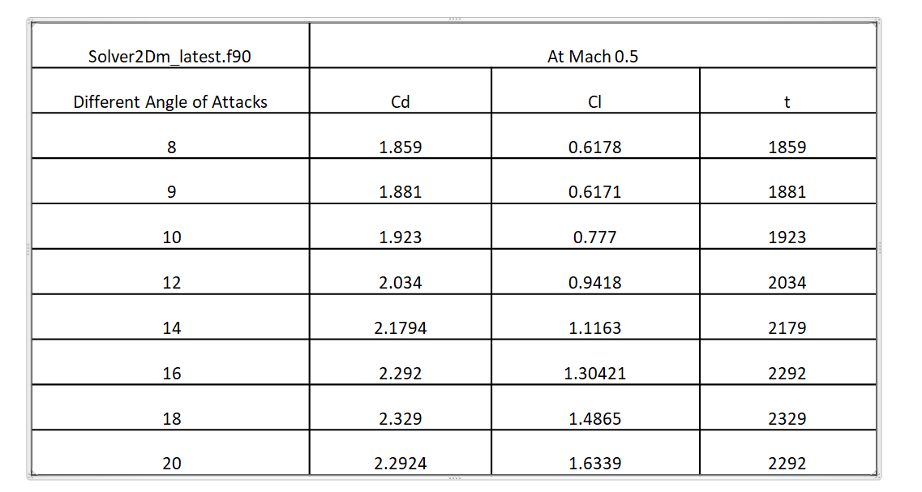

Table 4.2 Solver2Dm_latest.f90 results at marked point

**4.1(VIII) Lift and Drag vs time at Ma=0.5 and Viscous flow for marked point**

Fig 4.9 Lift and Drag vs time at Ma=0.5 and Viscous flow for marked point

**4.2 Strength of Vortex**

Circulation, which is a scalar integral quantity, is a macroscopic measure of rotation for a finite area of the fluid.

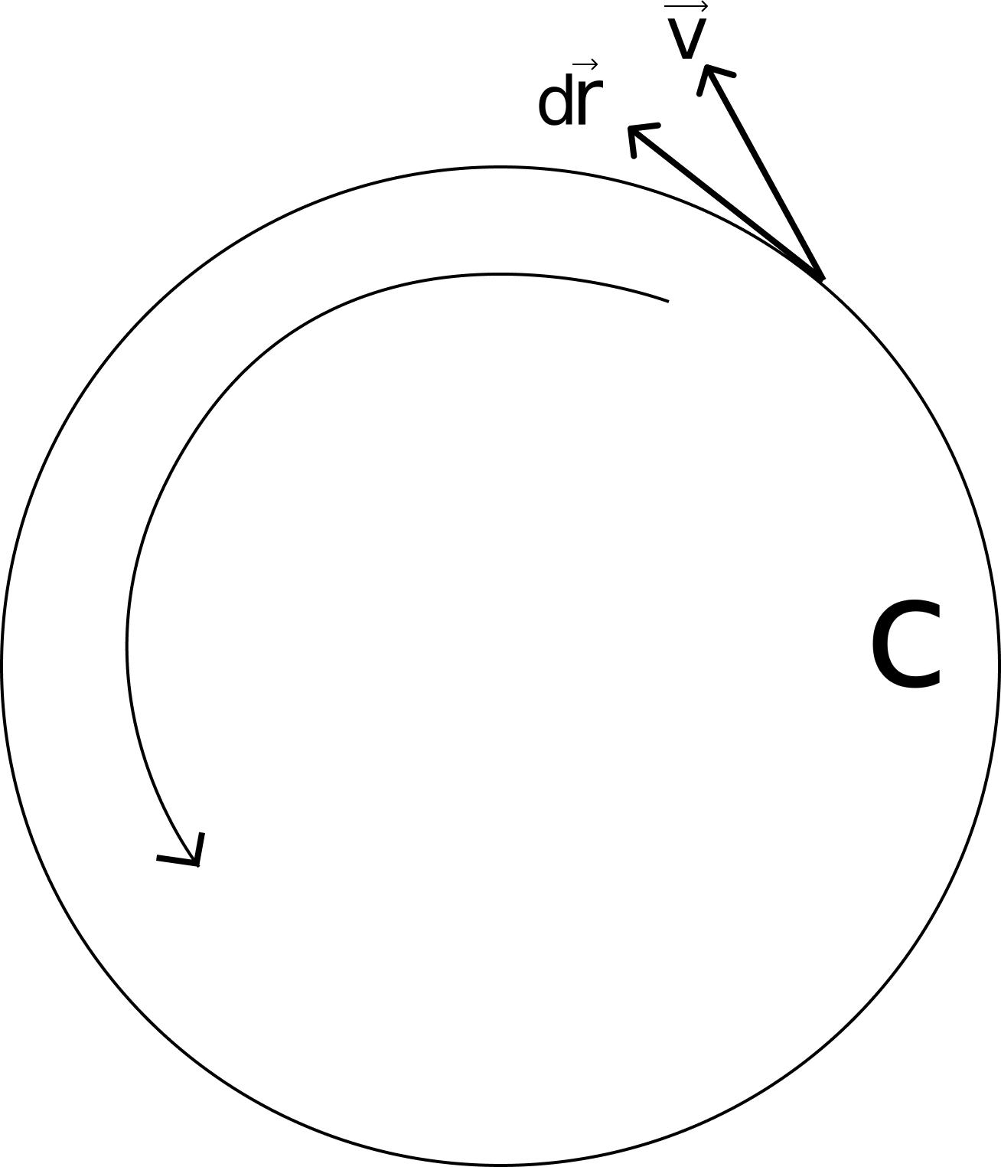

Fig 4.10

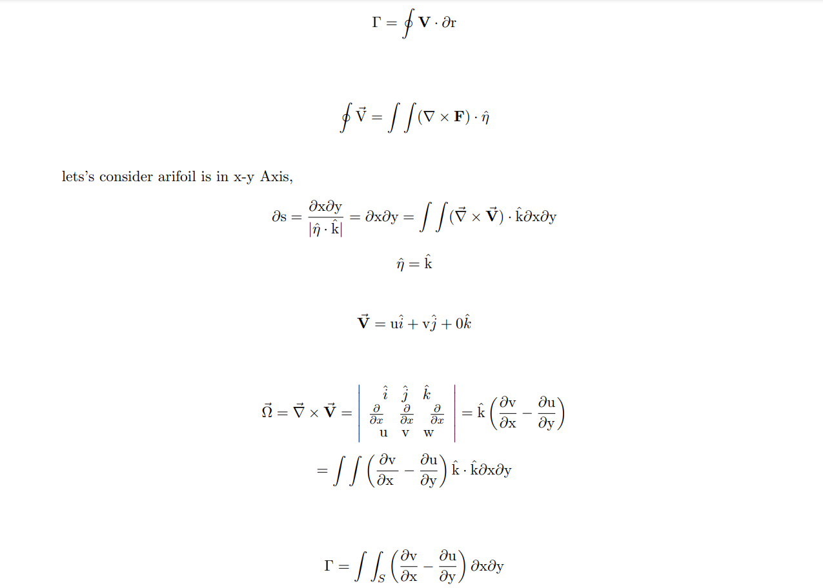

**4.2(I) Calculation of circulation at M=0.5 and different α**

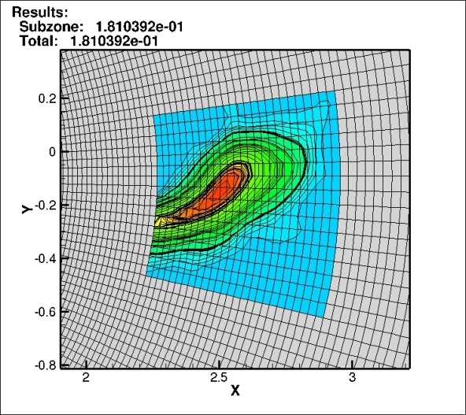 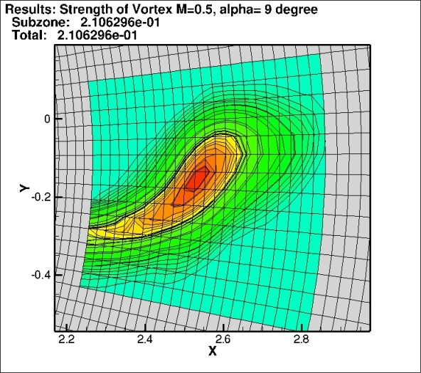

(a) α= 8o

(b) α= 9o

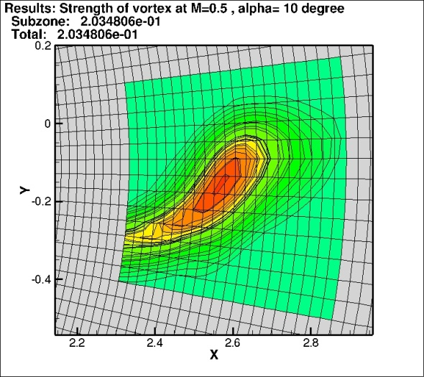 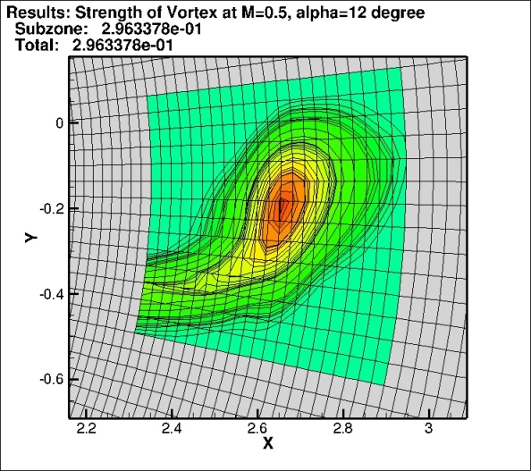

(d) α= 12o

(c) α= 10o

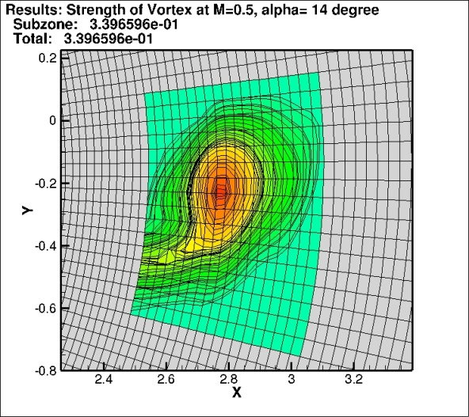 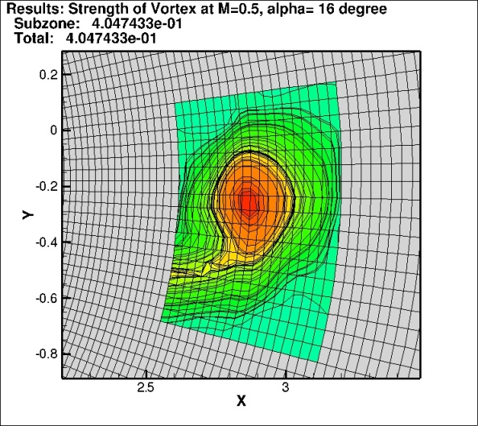

(f) α= 16o

(e) α= 14o

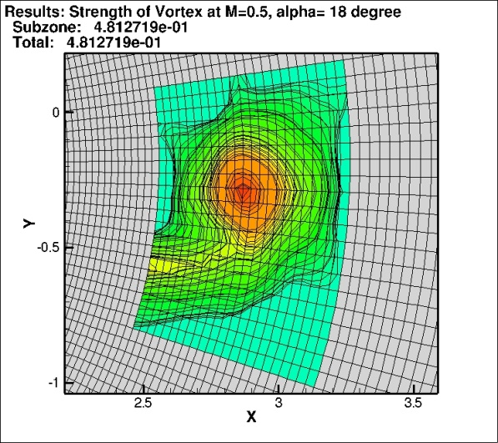

(g) α= 18o

Fig 4.11 Results of circulation at M=0.5 and different α

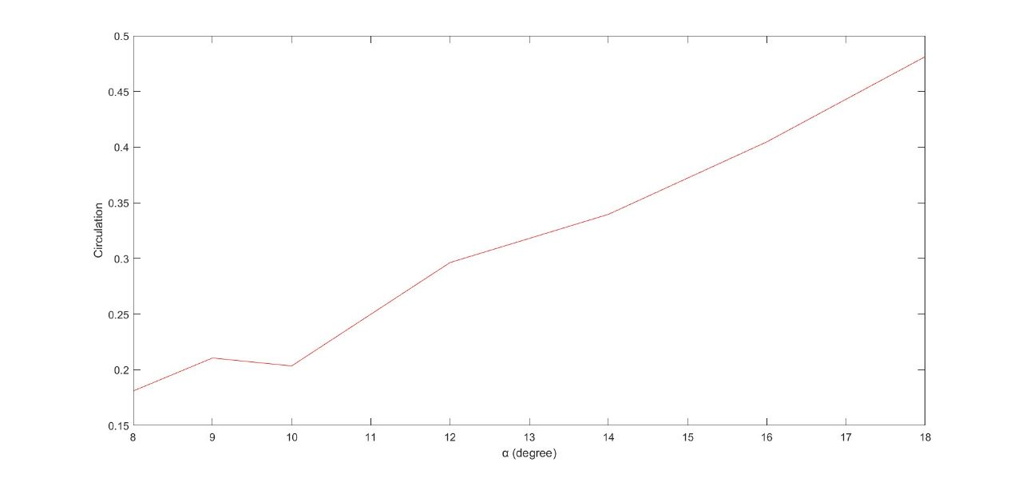

Fig 4.12 Circulation at Ma=0.5, α different and Viscous flow for marked point

#### 4.3 DESIGN METHODOLOGY II:

A numerical validation of the PVU-M+[16] technique is achieved by comparing results from Ansys with those obtained from PVU-M+. PVU-M+ Method is designed to the stationary object in a flowing fluid, which is a direct representation of the physical situation being modelled.

#### 

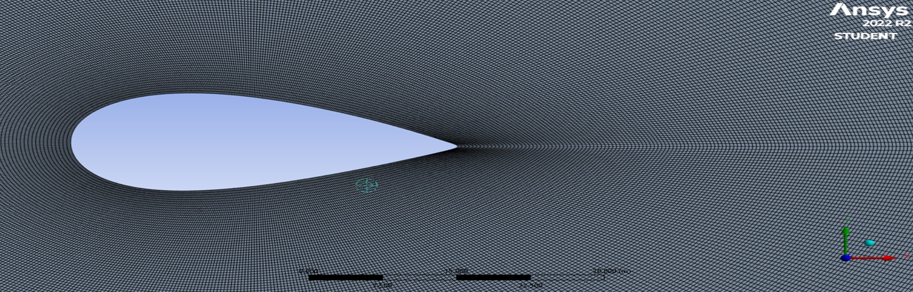

Fig 4.13 O Structured Grid Mesh

#### 4.3.1 Selection of Inviscid Models and Results

#### 

#### Fig 4.14

#### 

#### 

#### Fig 4.15

#### 4.3.2 Iterations

#### 

#### Fig 4.16 Lift versus Time

#### 4.3.3 Results

#### 

#### Fig 4.17 Comparison of Drag and Lift at different Ma and Angle of Attack

#### 

#### Table 4.3 Comparison of Ansys results and PVU-M+ method

#### 

#### Fig 4.18 Comparison of Drag and Lift for Ansys result and PVU-M+ scheme result

**CHAPTER 6: CONCLUSION AND FUTURE WORK**

### 6.1) CONCLUSION:

Work has been done in this semester: Calculation of circulation at M=0.5 and different angle of attack.

### 6.2) FUTURE WORK:

Our next step is to predict and analyzed NACA0012 Accelerating Airfoil

## REFERENCES

[1] G M Lilley, R Westley, A H Yates and J R Busing. Some aspects of noise from supersonic aircraft. College of Aeronautics, Report 71:396-414, March 1953.

[2] P H Oosthuizen and W E Carscallen. Compressible Fluid Flow. McGraw Hill, U.S.A., 1997.

[3] Fluent Inc. Fluent 6.3 User and Tutorial Guides. New Hampshire, U.S.A., 2007.

[4] R B Morrison and M J Ingle. Design Data for Aeronautics and Astronautics. Wiley, U.S.A., 1962.

[5] S F Hoerner. Fluid Dynamic Drag, theoretical, experimental and statistical information. Published by the Author, U.S.A., 1965.

[6] I H Abbott and A E Von Doenhoff. Theory of wing sections including a summary of airfoil data. Dover Publications, Inc., New York, 1959.

[7] M Tsubokura, T Kobayashi, N Oshima, K Kitoh, H Zhang, K onishi and T Tominaga. High performance computation of unsteady flow around a formula car using large scale les on earth simulator. 12th International Symposium on.

[8] I M A Gledhill, K Forsberg, P Eliasson, J Baloyi and J Nordström. Investigations of acceleration effects on missile aerodynamics using computational fluid dynamics. Aerospace Science and Technology, 13:197- 203, 2009.

[9] H Roohani and B W Skews. The influence of acceleration and deceleration on shock wave movement on and around aerofoils in transonic flight. Shock waves, 19, 4: 297-305, 2009.

[10] W C Selerowicz and A P Szumowski. Airfoil flow instabilities induced by background flow oscillations. Experiments in Fluids, 32:441-446, 2002.

[11] P Monnet , M Coutanceau, O Daube and T A Phuoc Loc. The use of visualization as a guide in the numerical determination of the flow around an abruptly accelerated elliptic cylinder or aerofoil. Proceedings of the Third International Symposium on Flow Visualization, University of Michigan, Michigan USA, 363-368, 1983.

[12] T K Sengupta, T T Lim, S V Sajjan, S Ganesh and J Soria. Accelerated flow past a symmetric aerofoil: experiments and computations. Journal of Fluid Mechanics, 591: 255-288, 2007.

[13] R H Ellsworth and T J Mueller. Airfoil boundary layer measurements at low Re in an accelerating flow from a nonzero velocity. Experiments in Fluids, 11: 368-374, 1991.

[14] R S Sawyer and J P Sullivan. Lift development of delta wings undergoing constant acceleration from rest. Journal of Aircraft, 28, 11: 735-740, November 1991.

[15] Victoria Rolandi, Laura, et al. "Stability of the low Reynolds number compressible flow past a NACA0012 airfoil." AIAA Journal 60.2 (2022): 1052-1066.

[16] Nadeem Hasan,S Mujaheed Khan, and Faisal Shameem. A new flux-based scheme for compressible flows. Computers and Fluids, 119:58–86, 2015.